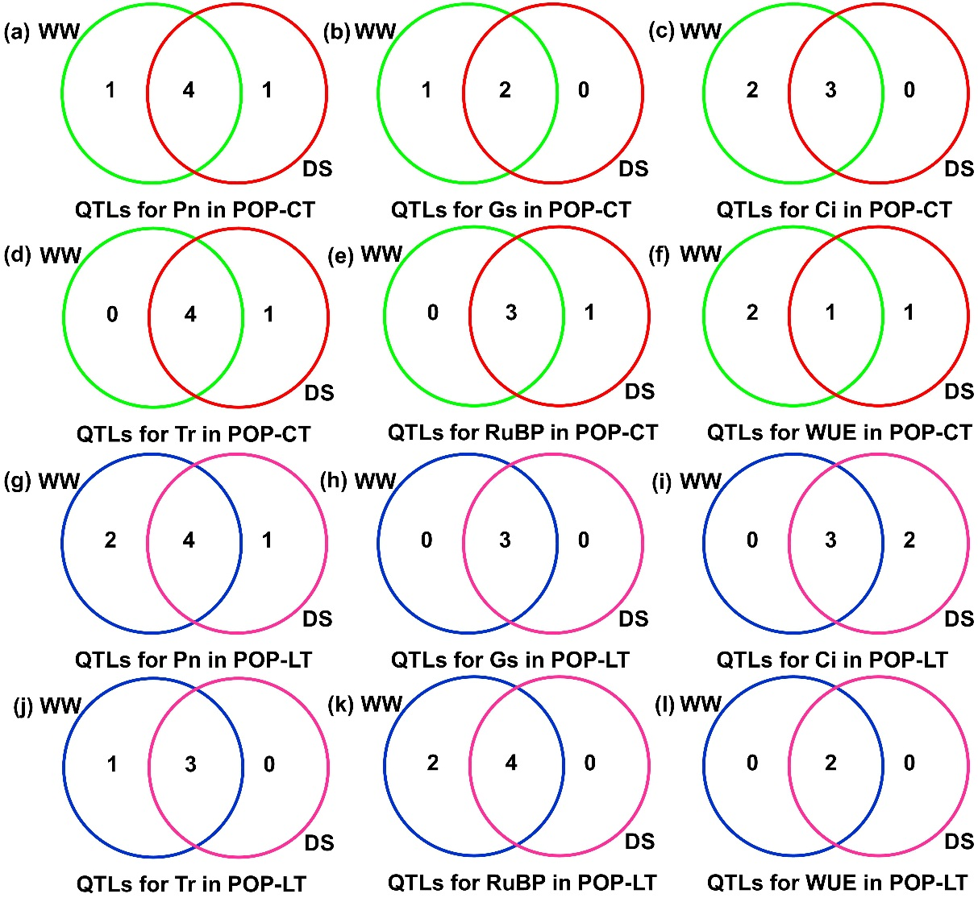
Additional file 7: Fig. S4 Venn diagrams of identified QTLs comparison for Pn net photosynthetic rate (a and g), Gs stomatal conductance (b and h), Ci intercellular CO₂ concentration (c and i), Tr transpiration rate (d and j), RuBP ribulose 1,5-biphospate carboxylase activity (e and k), and WUE water use efficiency (f and l) in two F₄ populations (POP-CT and POP-LT) by single environment mapping with composite interval mapping (CIM). The identified QTLs in POP-CT under well-watered (green/blue circle) and drought-stressed (red/pink) environments, respectively

